

Mobile Application Documentation

Group Project: SOC09109

Date Here

Authors: Paul Quigley & Josh Renwick

Mobile Sales Application

Table of Contents

Setup 3

System Requirements 3

Installation 3

First time use 3

# Setup

## System Requirements

In order to run this application you will need an android smartphone or tablet running android version 5.0 Lollipop or later which has a rear facing camera.

## Installation

Figure 1 Application Install

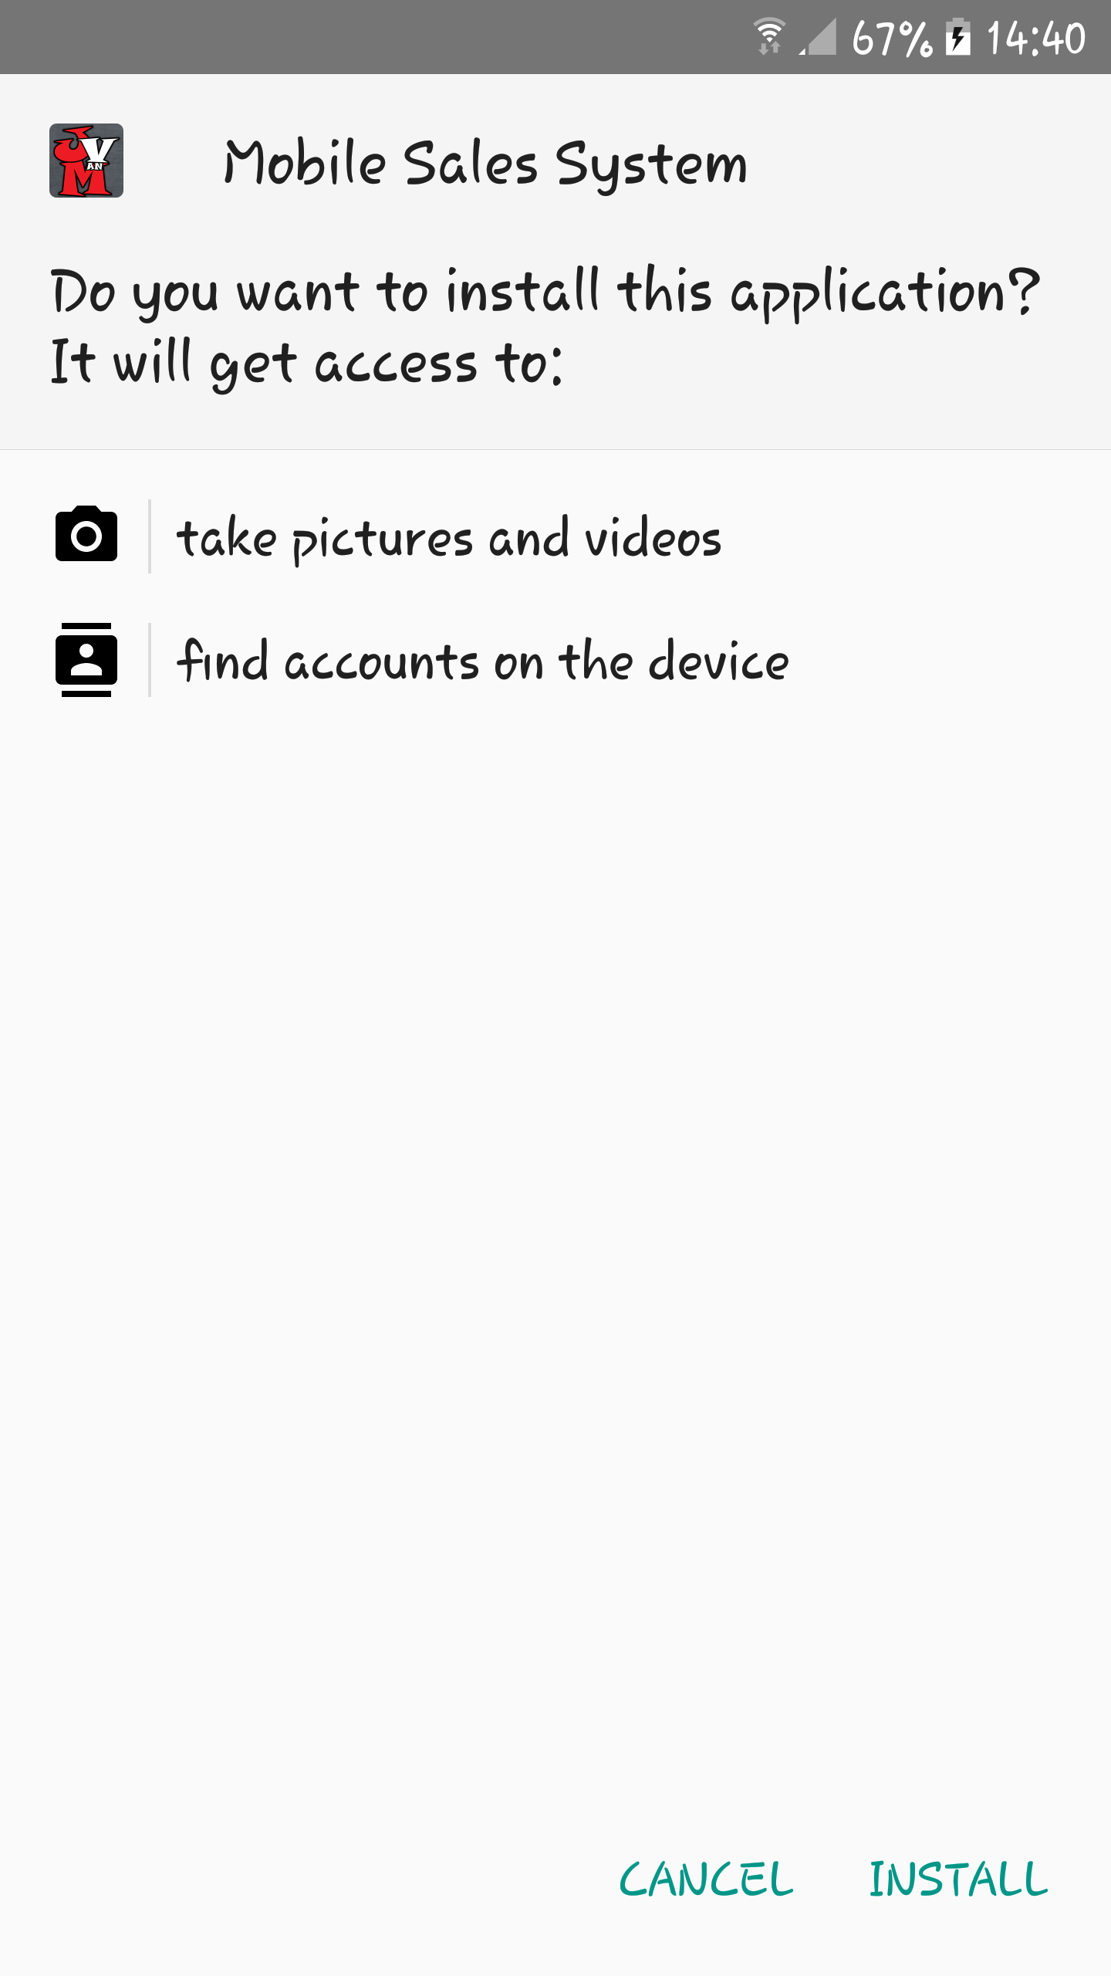The application is supplied as a .apk file which is to be downloaded to an android mobile phone which you intend to use. Once it is downloaded, navigate to where the file downloaded to and then install the application by clicking on the .apk file and after reviewing the permissions clicking install. (Figure 1)

Your device may alert you that it is set to block installation of applications from unknown sources. If this happens then you need to allow your device to install from unknown sources. On some devices, it is possible to allow this on a case by case basis, meaning that you can install this application but still have this setting turned off for other applications. Once you have done this the application should install and after that it is possible to open the application for the first time.

## First time use

When running the application for the first time it is necessary to configure where the app will look for the global database used for storing of stock information. To do this open the app and then click on the statistics button